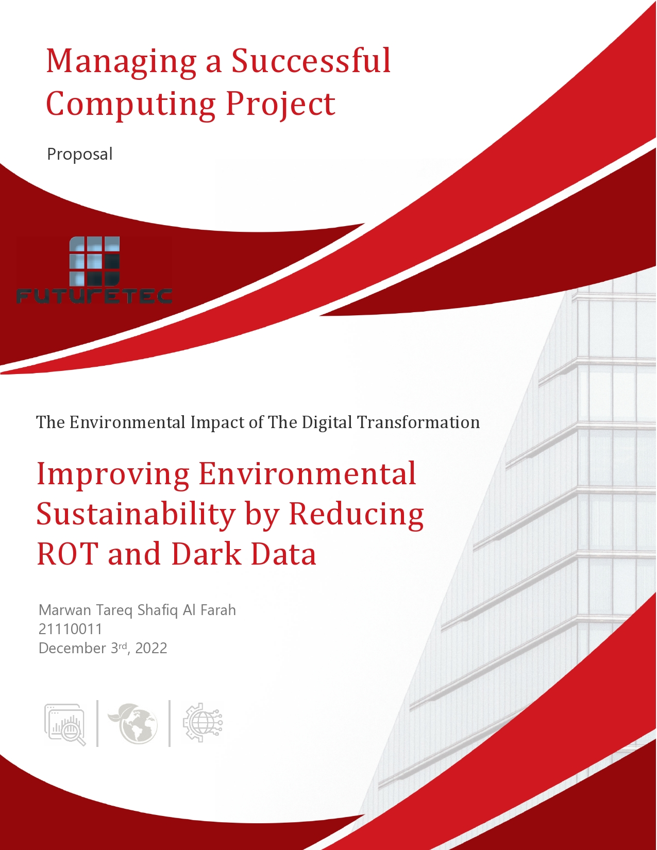

**Table of Contents**

***Proposal*** 2

**Stakeholders** 2

**Project Sponsor** 2

**Project Manager** 2

**Additional Stakeholders** 3

**Project Overview** 4

**Summary** 4

**Business Justification** 4

**Project Objectives** 5

**Deliverables** 5

**Executive Decision Record** 6

# ***Proposal***

|  |  |  |  |
| --- | --- | --- | --- |
| **Project Title** | Improving Environmental Sustainability by Reducing ROT and Dark Data | | |
| **Submitted by** | Marwan Tareq Shafiq Al Farah | **Project Type** | Computing |
| **Phone / Email** | +962 7 7013 7361 21110011@htu.edu.jo | **Total Estimated Budget** | 25,000 JOD |
| **Date of Proposal** | December 3rd, 2022 | **Version No.** | 1 |
| **Projected Start Date** | March 1st, 2023 | **Projected Completion Date** | August 31st, 2023 |

|  |  |  |  |
| --- | --- | --- | --- |
| **Stakeholders:** | | | |
| **Project Sponsor** Commissions delivery of and champion’s project; Provides vision and direction; Accepts responsibility | | | |
| Future Technology Systems Company (FutureTEC), the project's primary sponsor, is the organization that commissions the project manager to carry out the project and provides support for the project's objectives throughout all project management phases. Additionally, they accept responsibility and give the project its vision and direction by taking part in all of its phases (initiation, planning, excitation, monitoring and controlling, and closure), as well as by offering financial assistance when necessary and ensuring that the project is in line with the organization's goals and missions.  There are numerous internal and external stakeholders who have an impact on the project's success. Employees, managers, and shareholders are some of the internal stakeholders, whereas customers, local communities, governmental organizations, and suppliers are some of the external stakeholders. For example, employees are the individuals who effectively contribute to the smooth operation of FutureTEC by successfully completing all the tasks for which they were hired. They can, however, be quite resistive to any organizational changes, therefore we must make the transition to the new system as seamless as possible for them in order to maximize their contribution and impact to FutureTEC's success. An essential stakeholder at FutureTEC is the project manager, who will be discussed in more detail in the following section. Since the shareholders are FutureTEC's owners, they are also the project's sponsors as well as its financial supplier, and as such, they are crucial to the project's success as discussed above. As for local communities and clients, most local communities regularly protest in favor of the environment, and on occasion they even boycott specific companies that cause environmental harm. Because of its concern for the environment and the communities' pleasure with FutureTEC, FutureTEC will win the public's attention and achieve large financial advantages by implementing this project. Finally, aside from the shareholders, no suppliers or any governmental organizations will have an impact on the project. | | | |
| **Project Manager** Confirms need for project and validates objectives; Provides specs, monitoring, and overall delivery | | | |
| As the project manager, it is my responsibility to oversee the project's overall scope, the team, the resources, and the budget. I also play a vital role in the project's success as I must also take the lead when it comes to planning, executing, monitoring, controlling, and wrapping up a project. I also have the duty to establish a vision for the project's success, and to get everyone on the same page regarding the necessary steps to maintain and ensure the project’s success, as I am the liaison between FutureTEC, the clients, and the sponsors. | | | |
| **Additional Stakeholders** | | | |
| **Stakeholder Name** | **Stakeholder Role** | **Stakeholder Impact** | **Contact Info** |
| Feras Al Oqlah | CEO - He is the person who oversees all operations in the company, ensuring that the day-to-day activities continue to operate smoothly, managing the company's strategy, public relations, and many other responsibilities | Because of his influence over lower levels of management and the fact that everyone is affected by the CEO’s leadership style, the CEO plays a vital role in the success of the organization and the project. | [Linkedin](https://www.linkedin.com/in/feras-al-oqlah-25877a3?lipi=urn%3Ali%3Apage%3Ad_flagship3_profile_view_base_contact_details%3BDeFOjEXQSLqgueT6CF2ecw%3D%3D) |
| Majd Farahat | Cloud Business Unit Manager – She assists in enhancing IT and business strategies, policies, and techniques by serving as a consultant as well as helping accelerate all system-related management, maintenance, development, and performance. | She manages the company's cloud business unit, thus, she contributes to the success of the business by ensuring that all operations performed on the cloud are done correctly, fixing any issues that arise during the implementation of the project, and providing guidance to peers and less experienced employees. | +962 7 9675 8748 [majd.farahat@futuretec.me](mailto:majd.farahat@futuretec.me) [LinkedIn](https://www.linkedin.com/in/majd-farahat-5b3ba551/) |
| Obada Suliman | Network Engineer - To maintain network security, he is largely responsible for setting up, maintaining, and supporting firewalls. He is also in charge of configuring tools like routers or switches that ensure the IT infrastructure of a business operates efficiently. | He can have an impact on the business success by ensuring the data’s security as well as ensuring that all clients have 24/7 access to their data on the cloud and by resolving any issues as soon as they arise. | [LinkedIn](https://www.linkedin.com/in/obada-suliman-556b77178?lipi=urn%3Ali%3Apage%3Ad_flagship3_profile_view_base_contact_details%3B8aWMZzbFTX%2BhcR1D5oa17A%3D%3D) |
|  | | |  |
| **Project Overview** | | | |
| **Summary** | | | |
| The plan is to reduce the Dark (data that is maintained but only occasionally or possibly never used) and ROT data (Redundant, Obsolete, or Trivial data) to the point where many servers will become available and no longer be needed. As a result, the servers that are no longer needed can be kept in the facility's storage rooms for potential use in the future. When needed, we refurbish these servers using modern cutting-edge technology and repair any broken parts before bringing them back into service. After that, any e-waste created during the process of repairing and refurbishing these servers, will be recycled rather than being thrown out, reducing our overall amount of e-waste.  Reducing the amount of Dark and ROT data can be accomplished by utilizing tools like Aparavi's intelligent data management platform, which enables you to scan and classify all of your enterprise's data in order to locate, relocate, or delete both Dark and ROT data from your firm.  Meanwhile, the company can update its systems with new data retention guidelines. Every new piece of data that will be kept in the datacenter needs to be marked with the duration for which it will be required, such as "One Week", "One Month", "One Year", "Five Years", or "Forever". Similar to how security cameras record video for a predetermined amount of time before deleting it, the data will be automatically deleted after that time period has passed.  The plan is to train the entire team on how to utilize the new data retention guidelines system, which the business will use to run its entire operations, during the course of this project's execution. | | | |
| **Business Justification** | | | |
| According to the primary and secondary data analysis, there is a serious problem with how people deal with data in general. People prefer to keep their data and hoard it rather than delete it whether they need the data or not, which causes both ROT and Dark data to accumulate over time as it reaches a point that this data accounts for 85% of all data saved. This behavior also reflects how corporations handle data retention, but the difference between them and average people, who may only have a few terabytes of data, is that organizations store many terabytes and petabytes, and in some cases, exabytes, of data. Keeping that much data causes massive pollution and a massive carbon footprint.  FutureTEC asked us to investigate the possibility of refurbishing, repairing, and recycling digital devices rather than replacing them in order to find solutions to reduce their environmental effect as a result of their digital transformation. Using the project's initial concept, which is thoroughly explained in the summary, we were able to achieve all of the business objectives. The concept of reducing the environmental impact of digital transformation served as the foundation for the entire scheme. We were able to address all business objectives by repairing and refurbishing the servers before reuse again. In addition, we were able to recycle the leftover materials from the refurbishment rather than throwing them away as e-waste, which allowed us to meet all of the business requirements.  Although the project will cost thousands of dollars to implement and to buy the new technologies, it will ultimately save the corporation hundreds of thousands or perhaps even millions of dollars in addition to helping the environment. Additionally, by eliminating all ROT and Dark data, staff members will be able to use the organization's system more effectively, making it simpler and safer for them to access data, improving the quality of their job, their productivity, and cutting down on their time. | | | |
| **Project Objectives** | | | |
| * The main goal for this project is to reduce the negative environmental impact of digital transformation that is associated with FutureTEC, by refurbishing, repairing, and reusing digital devices rather than replacing them. * Reducing the quantity of Dark and ROT Data stored in datacenters. * To require significantly fewer servers to perform the same tasks rather than hundreds, thousands, or even tens of thousands of servers. * To significantly reduce the amount of energy that these datacenters consume whether it is for cooling the servers or running them. | | | |
| **Deliverables** | | | |
| The project's outcomes will be that FutureTEC and its partners' systems will have extremely low levels of Dark and ROT data due to the use of their new data retention guidelines system and intelligent data management platform. As a result, fewer servers will be required in the "Joud Cloud," which will lower the cloud's energy consumption and significantly decrease the environmental impact and carbon footprint of these businesses. Another result will be a reduction in these corporations' expenses, which will increase their profitability as they save thousands or even millions of dollars by holding less and less data.  The changes that will happen in FutureTEC are planned internal changes and they will be implemented using the Pilot Changeover method which entails deciding on a certain branch or area (pilot site) of FutureTEC and putting the system in place there first to test the system on a small scale to make any necessary adjustments to prevent any issues when it is later implemented throughout the entire organization and its partners.  As for the management of stakeholders, it is the process of shaping, overseeing, and upholding relationships with stakeholders on a project before, during, and after the implementation of the project, because the success of a project is largely dependent on how well stakeholders' requirements and expectations are managed. As stated in the summary, FutureTEC's complete staff will receive training on the new system as part of stakeholder management. In addition, any ideas they may have will be taken into consideration, and their expectations will be heard. The new system will be put to the test on a representative sample of each type of stakeholder that uses it during the project's execution in order to get their feedback and make adjustments based on their needs. As for after the project’s implementation, any assistance that the stakeholders may require will be provided to them.  Finally, because not all stakeholders will support the project's implementation and the resulting changes to FutureTEC's system, some may even oppose it, it is imperative to fully explain it to all stakeholder effected by it, by outlining why it is necessary and how it will be implemented. | | | |

|  |  |  |
| --- | --- | --- |
| **Executive Decision Record** | | |
| **Date** | **Approved By** | **Decision** |
| - | - | - |
| - | - | - |
| - | - | - |
| - | - | - |